Backup - Manual Backups

I strongly recommend you do a manual backup before updating. A manual backup uses a lot of disk space, but it backs up all critical files quickly and in a usable form. It will save the selected items in the AUTOBACKUP folder.

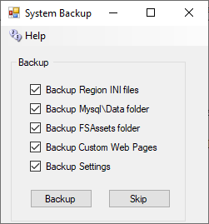

Some of these boxes may be grayed out or uncheckable because the system has not installed that service.

Region INI files All files from Opensim\bin\Regions are copied. The useful ones are in the bin\Region\DosBoxName\Region\folder

MySQL\Data folder: This is the database. The rest of the folders in MySQL are just code or changeable settings that come in an update.

FSassets Folder: If you are running the FSAssets system, this contains just the assets of the database. You still need to backup MySQL.

Custom Web Pages: This backs up two folders in bin\WifiPages-Custom and WifiPages-Custom in case you have made changes.

Settings: This copies the Settings.ini. All settings come from this file.

